A short report on Revit 2013 API Webcast on 17 May 2012

* Number of registrations: ~120
* Number of participants: ~54
* Poll responses :

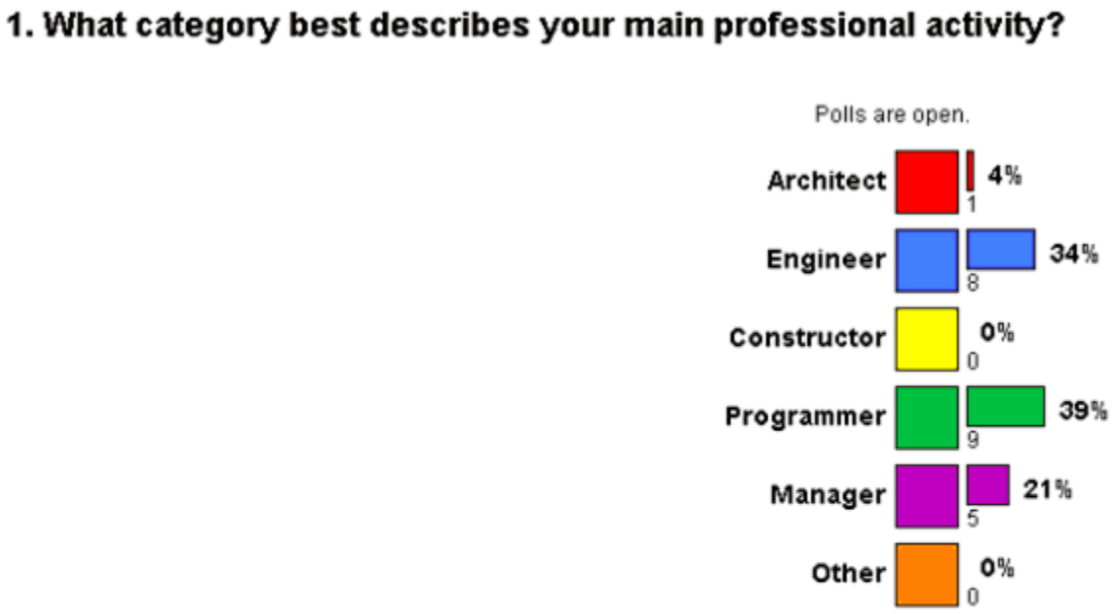

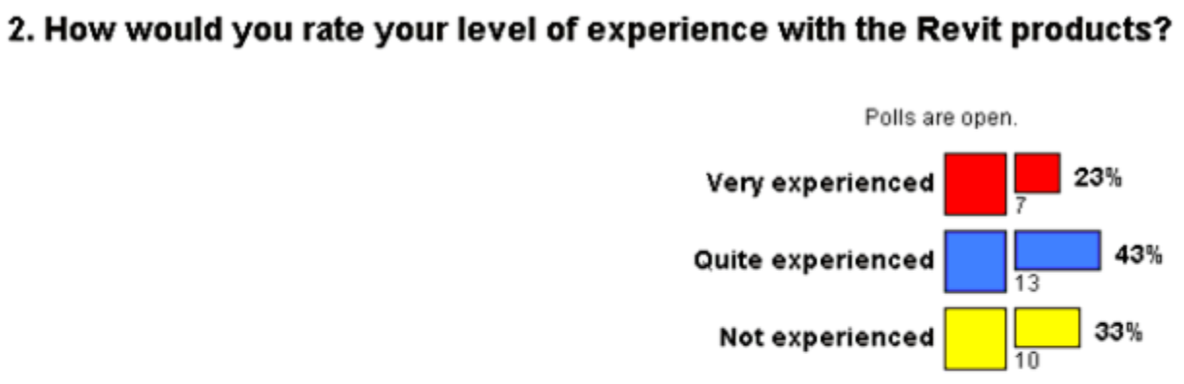

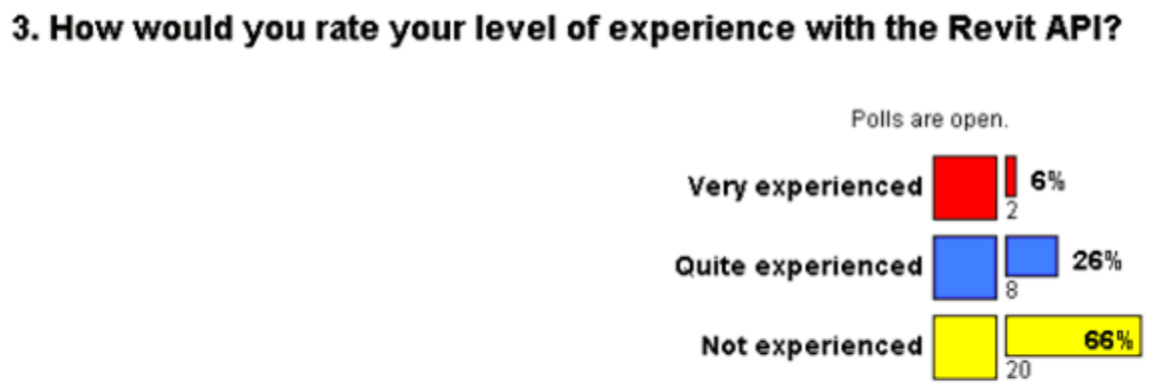

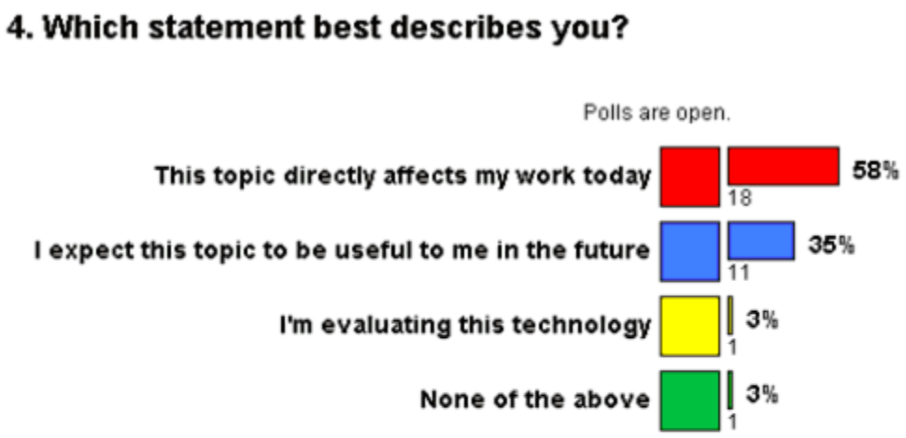

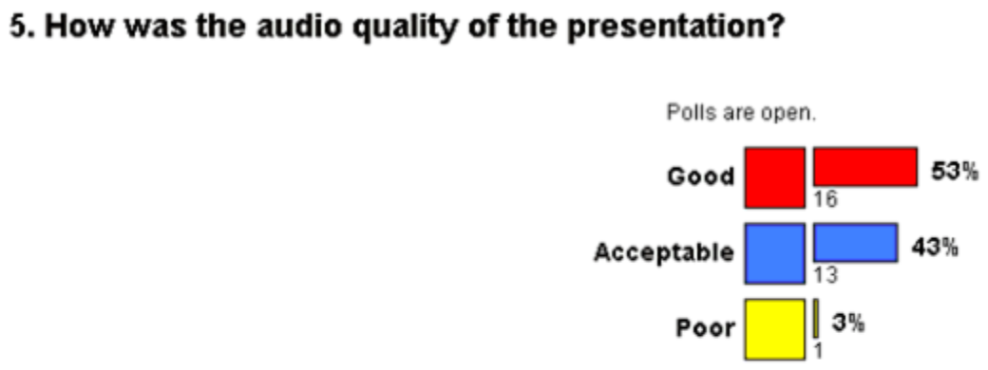

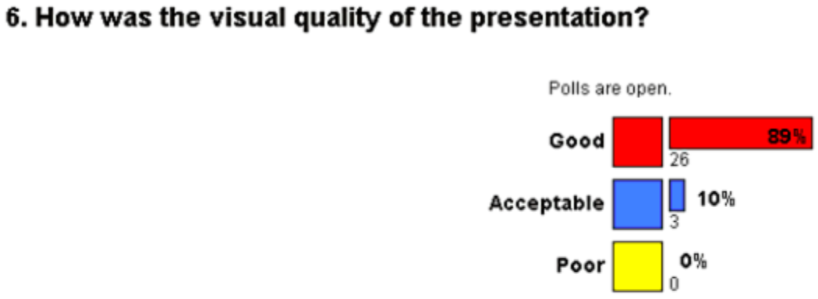

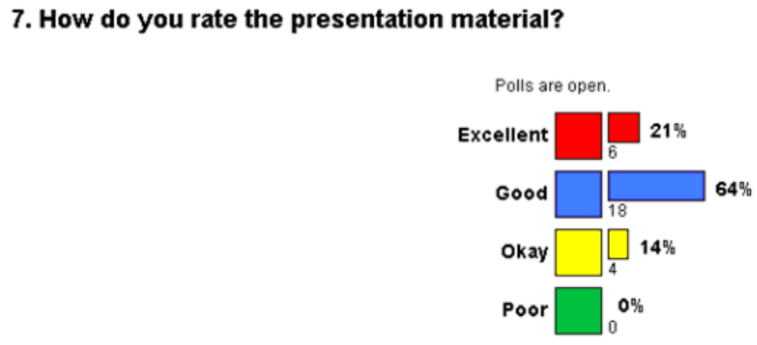

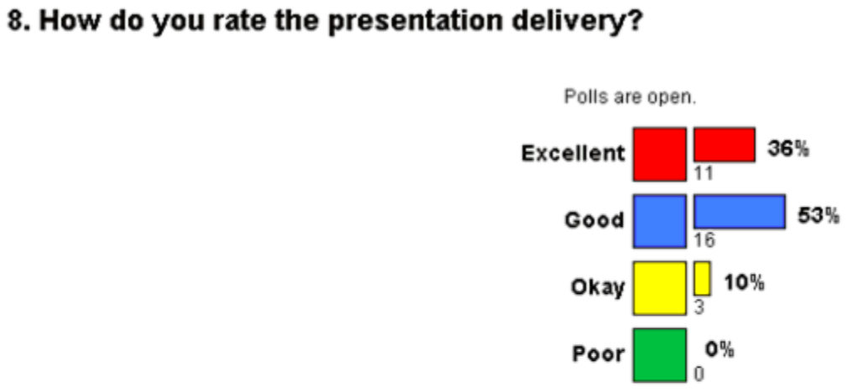

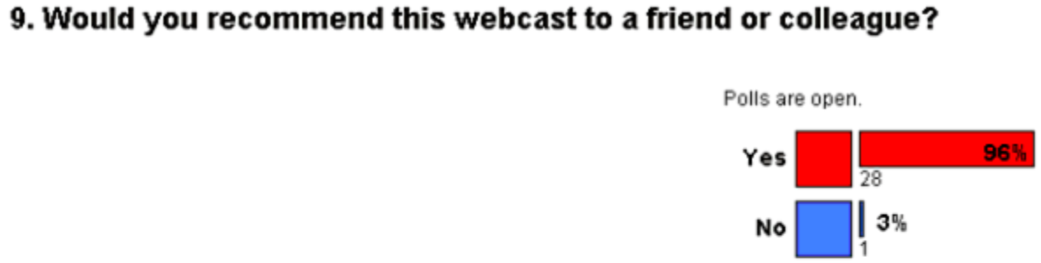

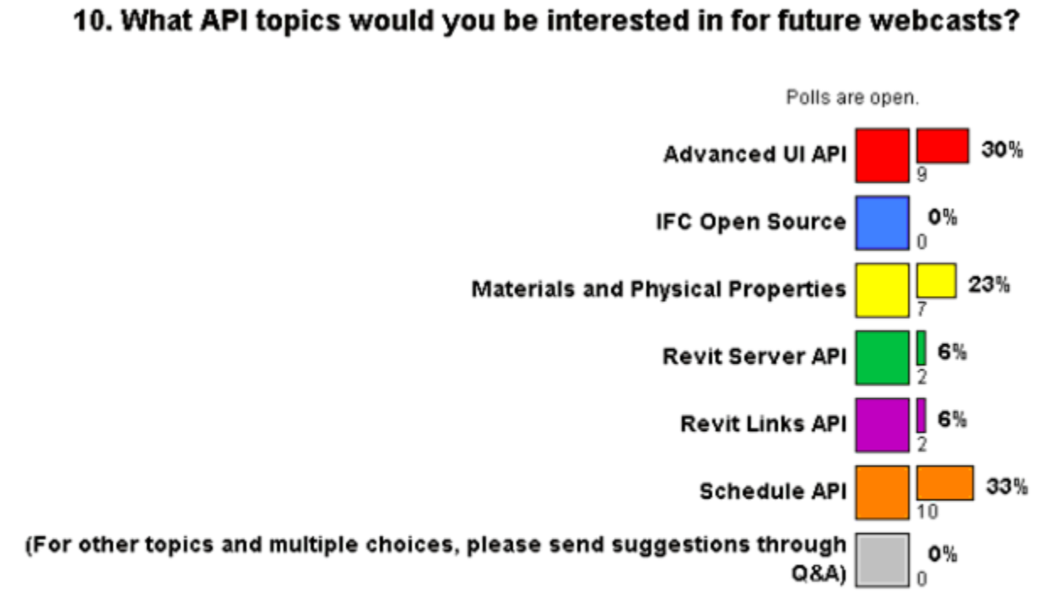

**Summary of the questions answered through Q&A console by Saikat and Mikako**

S **Asked:** the selection of doors and windows are possible with the use of filer in Revit without API, so what the meaning of it?

Saikat Bhattacharya **Answered:** sorry for the confusion, the filter is part of the API

S **Asked:** Is it right? In revit you can filter all the windows, but through revit api, you could filter a window with certain size?

Saikat Bhattacharya **Answered:** yes that correct, you can use the FilteredElementCollector and pass in the class (FamilyInstance), category (OST_Windows) and Type (the specific size) and you should be able to get what you need.

Nabil Kherouf Asked: Hi How can I scan ( filter the elements) a certain specific area in the document?

Saikat Bhattacharya **Answered:** You can use the BoundingBoxIntersectsFilter to use a Bounding Box to filter elements contained in it. With the API you can also filter all the windows if you want to just by using the Class and Category filter (without specifying any type).

William Song Asked: Is there an API that I can use to edit a wall profile?

Saikat Bhattacharya **Answered:** Sorry this is not possible at the moment, I would think you can delete the wall and create a new wall in that location with a profile you desire to workaround this. http://thebuildingcoder.typepad.com/blog/2011/07/create-gable-wall.html shows how you can have gable wall - a wall with non-regular profile

William Song Asked: Where to download this video of this webcast?

Saikat Bhattacharya **Answered:** We will be making the recording available via the ADN and the API training schedule (the same place where you registered for this webcast from)

alper Asked: Hi I just wonder, If I develop very useful add-in how can I sell? Is there any way to prome it through autodesk?

Saikat Bhattacharya **Answered:** yes, Please look at the Revit Exhange Store. Via apps.exchange.autodesk.com

William Song Asked: Is there any api that can be usd to access Revit DB Link?

Mikako Harada **Answered:** You are talking about DB Link on the subscription? I don't think there is API for that. But DB link is written in public API. So you should be able to do the similiar with the API.

Chris Goemans Asked: 1. With the upcoming release of Visual Studio version 11, can it be used for programming with the Revit API? 2. Can the Revit API be used for reading and writing (exporting) gbXML files?

Saikat Bhattacharya **Answered:** 1. The requirement is to have .NET framework 4.0.

The API has an Export method on the document object which can help you export to GBXML format from Revit using API

Sergey Babitsky Asked: Do you planning to add some ability to select all values of parameter (i mean distinct values) to collect them all at one query?

Saikat Bhattacharya **Answered:** the filtering mechanism is based on LINQ queries and I believe this should be possible

William Song Asked: I do not understand UV coordinate. Is it the same thing as XY Coordinate?

Saikat Bhattacharya **Answered:** http://en.wikipedia.org/wiki/UV_mapping

William Song Asked: Can the tree view structure (e.g. the nodes) in Project Manager be accessed through API?

Saikat Bhattacharya **Answered:** You can access specific views (like plans, sheets etc) but API does not access the tree nodes programmatically unfortunately

My overall experience:

This was my first webcast. Mikako and Jeremy provided much needed guidance.

It was good learning experience to present before a large audience. While I prepared for the webcast, I learnt some additional Revit basics that I hadn’t learnt:

* Editing the RvtSamples.txt
* Use of manual transaction mode
* Use of the regeneration mode
* Gained better understanding of the Revit API hierarchy
* Explored the extensible storage

Also found a few areas that I still need to improve on:

* Handling telephone conferencing during the webcast – I heard a few people talking in the background when Jeremy was presenting and then realized that the phone lines had been unmuted during the 5 min break. I then tried to mute all the lines while Jeremy was still speaking and this resulted in Jeremy not being heard for a few minutes. Sorry about that.
* During the initial part of the presentation, many attendees weren’t hearing me loud enough. I need to improve on this by speaking closer to the phone or use a headset.